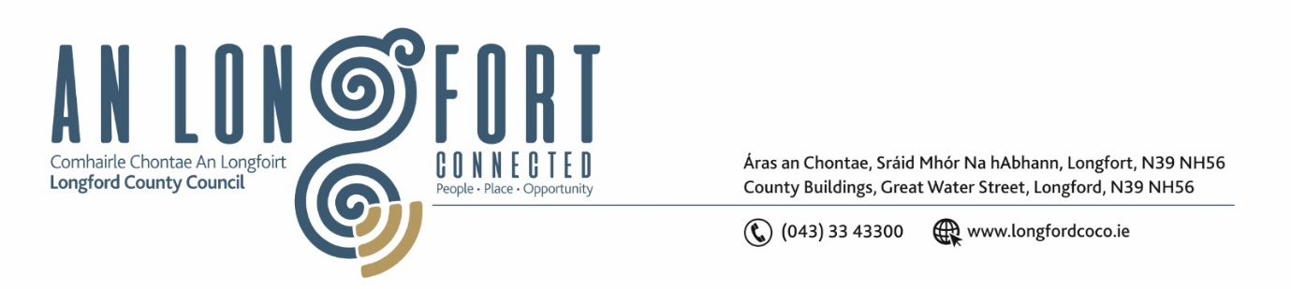

***LONGFORD MUNICIPAL DISTRICT***

***Please note meeting will be held in the Council Chamber, Aras an Chontae and via Microsoft Teams***

**16 June 2022.**

**To: Each Member of Longford Municipal District.**

**Dear Member,**

You are requested to attend the Meeting of Longford Municipal District to be held in **the Council Chamber, Aras An Chontae** and **via Microsoft Teams** on **Wednesday 22 June 2022 at 3.30pm** to transact business, as set out on the Agenda hereunder.

**Yours sincerely**,

Ann Marie Mc Keon

_______________

**Ann Marie Mc Keon**

**Meetings Administrator.**

**AGENDA**

Prayer before meeting.

**1.** Confirmation of Minutes:

1. Longford Municipal District Meeting held on Wednesday 25 May 2022 – copy enclosed.
2. Longford Municipal District Committee Meeting held on Wednesday 25 May 2022 – copy enclosed.

**2.** Matters arising from Minutes.

**3.** Declaration of Interest by Members.

**4.** Management Report - enclosed.

**5.** Community Grant Support Scheme 2022 / Municipal District Grant – enclosed.

**6.** Consideration of Part VIII – Number 91- Conversion of an existing former healthcare facility to

two number two-bedroom dwellings and all ancillary works at 2 Woodview, Newtownforbes County Longford in Accordance with Section 179 of the Planning and Development Act 2000 (as amended) and Part 8 of the Planning & Development Regulations 2001 (as amended) – enclosed.

**7. Notices of Motions, submitted by Councillors, as listed hereunder –**

**Seamus Butler**

‘That Longford Municipal District adopts a strict protocol on temporary postering for events and other purposes. This protocol should include permitting, number of posters, duration of posters, how and where they are attached and a removal period among others that are open to suggestions’

**Gerry Hagan**

"I call on Longford MD to carry out repairs & replacement on the pavement slabs on the footpaths on New Street and Dublin Street. The pavement slabs are in a very dangerous state currently and the paths are a serious hazard to all pedestrians and business who operate along these very busy streets."